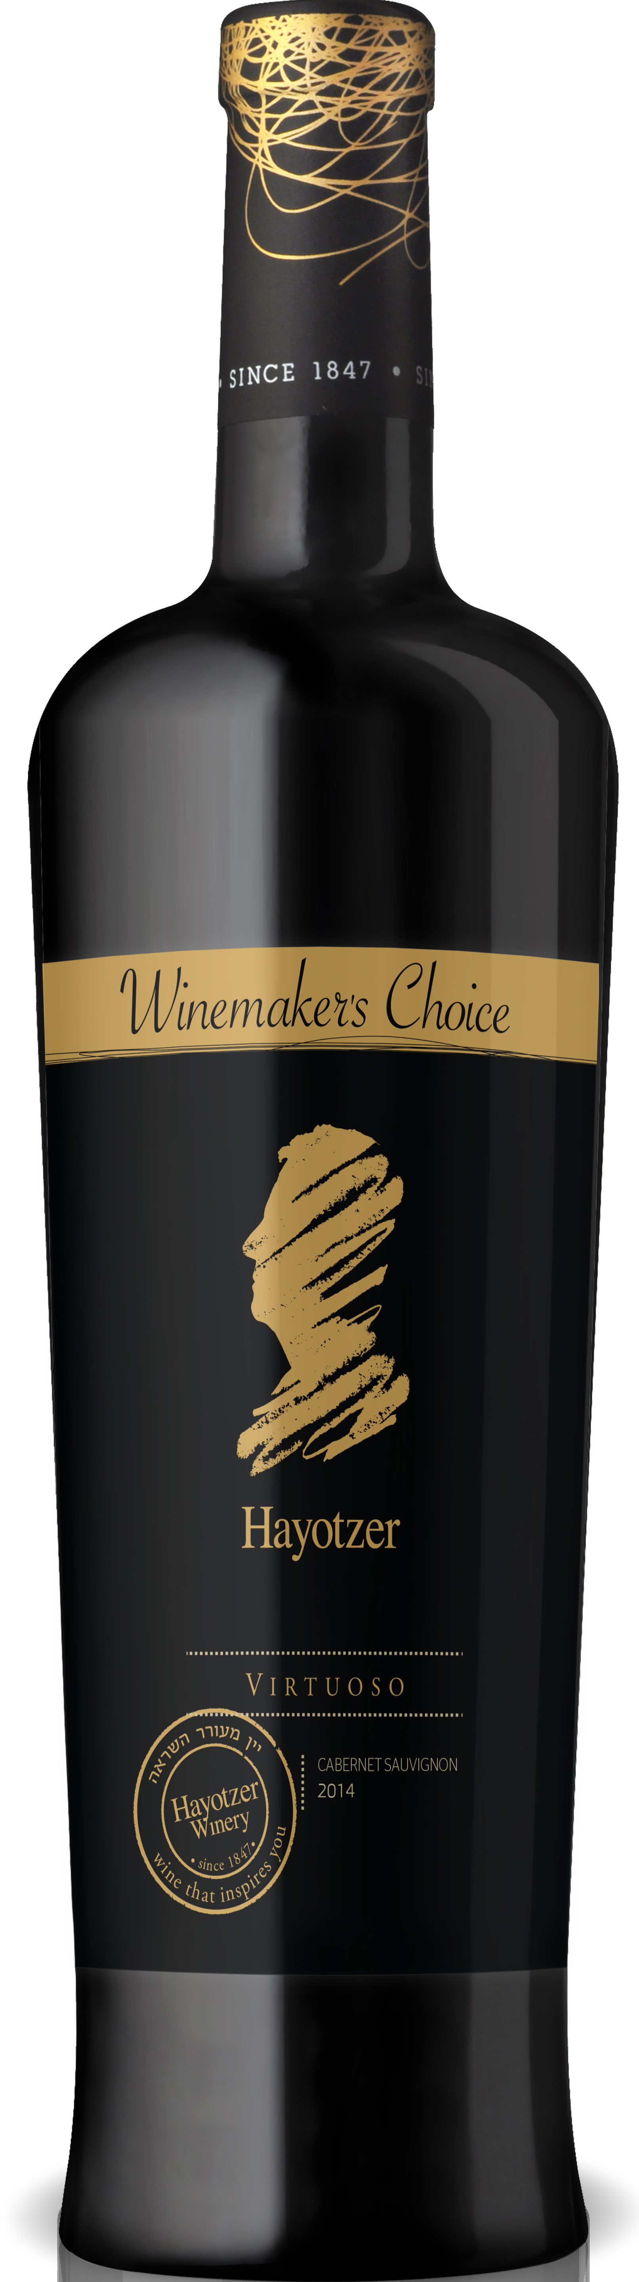
Virtuoso Cabernet Sauvignon

Grape variety: 100% Cabernet Sauvignon

Grape origin: The Cabernet Sauvignon grapes were harvested from a vineyard that is located on the rocky and mountainous terrain on the plats of the highest mountain of the Judean Mountains, at an altitude of 700 meters above sea level. The vineyard is planted along the shallow soil of medium depth which is challenging for the vines. This helped the small berries to achieve the result of a rich concentration of flavors and color.

Harvesting: Hand picked early in the morning

Wine production process: The handpicked grapes arrived to the winery during the early morning hours. Upon completion of the alcoholic fermentation the wine went through a low pressured slow press program and the wine was transferred into new French Oak barrels for malolactic fermentation in order to stabilize and soften the wine. Upon completion, the wine continued to mature in the barrels for 12 months and after it was bottled the wine continued its maturation process in the bottles for an additional 8 month period.

Wine description: The wine has intense red color with rich bouquets of ripe fruits, raspberries, coffee and roasted French Oak. The mouthfeel is pleasant, full and balanced with a taste of dried fruits. The lasting finish is good and enduring.

Consumption: From the day of release, however, the wine should continue to mature nicely over the next few years.

Serving recommendation: Best served at 18ºc with casseroles or beef in thick sauces.

