

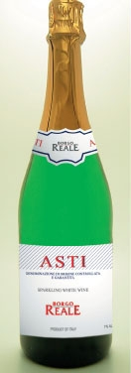
ASTI DOCG

7% ALC
Style: Sparkling, semi sweet
Mevushal
Kosher For Passover
Under supervision of OU and Rabbi Schwartz

Asti or Asti Spumante is a DOCG white sparkling wine produced in an area to the south of the town of Asti in Piedmont, Italy. Made from the Moscato Bianco grape, it is sweet and low in alcohol, and often drunk with dessert.

Serving Suggestion:
Should be served at 41F, which is almost out-of-the-fridge temperature. Goes very well with sweet desserts - a dish of strawberries, a sweet peach pie. It is the perfect summer time drink - light and sweet.

!!!ONLY KOSHER DOCG ASTI!!!
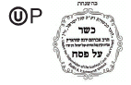

Allied Importers U.S.A
11-43 47th Avenue
Long Island City NY 11101
(718) 472-1155

